|  |
| --- |
| IWD6 |
| Trader.co.uk Website Design Artefacts |
|  |

|  |
| --- |
| IWD Team06  1-4-2022 |

**Contents**

Page 1: Formal Requirements

Page 2: Use Case Diagram

Pages 3 - 12: Use Case Descriptions

Page 13: Class Diagram

Pages 14 - 17: Initial Wireframe Design Diagrams

**Trader.co.uk Formal Requirements**

**Functional Requirements**

* Trader will be able to provide one or more Profession (implemented)
* Trader will be able to provide Images of previous work (implemented)
* Trader will be able to provide Hourly rate (implemented)
* Trader will be able to provide Professional certification (implemented)
* Trader will be able to view unique access pin (implemented)
* Guest will be able to search for tradesman based on a particular trade (implemented)
* Guests will be able to limit the result to a particular date or range of dates (implemented)
* Guests will be able to rate tradesman’s work after providing access pin (implemented)

**Non-Functional Requirements**

* Trader should select professions from a curated menu
* Website able to generate a unique code for tradesmen(?)
* Tradesmen with certification comes up first when searched

**Assumptions**

* Site Admin will be able to sign in using email and password
* Site Admin will be able to delete Trader Profiles
* Site Admin will be able to edit and delete Viewer reviews
* Trader will be able to provide availability (dates that they can do work)
* Trader will only be able to create one profile
* Trader will be able to sign up using email, name and password
* Trader will be able to sign in using email and password
* Guests will be able to provide their phone number, so as to give jobs to traders
* Guests will be able to see tradesman’s profile without an account
* Guests will be able to search for tradesman based on a tradesman’s profile name
* Website should meet the WCAG 2.1 (Accessibility)
* Website should be GDPR compliant (Data Privacy)
* Website should be compatible on Edge, Chrome, Firefox, Safari
* Website should be available 24/7
* Website should be responsive
* Trades should never be able to update their rating
* Guests should never be able to update a trader profile

**Roles**

* Trader
* Site Admin
* Guests

**Use Case Diagram**

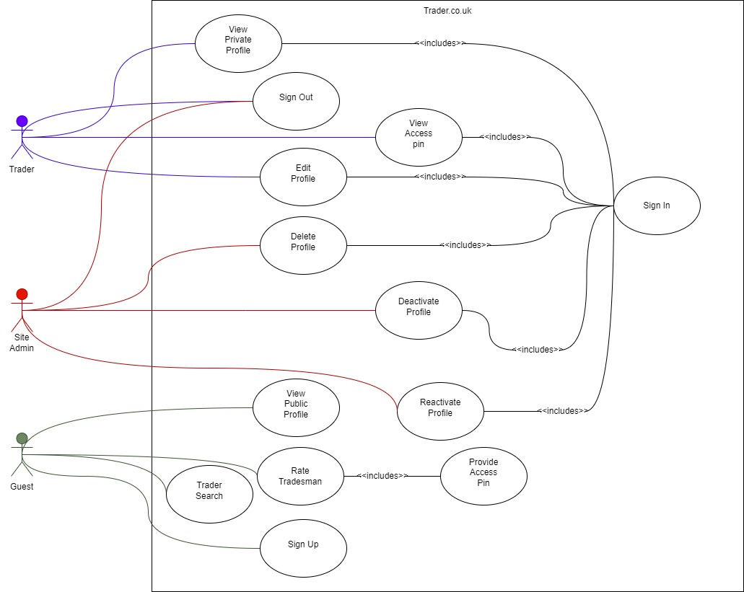

Figure 2**.**1 Use Case Diagram

**Use Case Descriptions**

Use Case: Sign Up

|  |
| --- |
| Precondition:  Guest has navigated to the sign in page |
| Actors: Guest |
| Description:   1. User selects Sign up option 2. System redirects to the sign up page 3. System redirects to the account creation page 4. Actor inputs required details into appropriate field (Surname, Firstname, username, email, password etc) 5. User submits details 6. System redirects to sign in page |
| Alternate steps:   * 1. User enters an existing username or email   2. System displays error for existing email   3. User is taken back to step 4   4. User leaves username or email empty   5. System prompts user to fill empty fields   6. User is taken back to step 4 |
| Post Condition:  Guest successfully opens an account |

Figure 3.1 Sign Up Use Case

Use Case: Sign In

|  |
| --- |
| Precondition: Actor has signed up and is on the website homepage |
| Actors: Trader |
| Description:   1. Actor selects sign in 2. System redirects to the sign in page 3. Actor enters email and password 4. Actor submits 5. System checks credentials 6. System redirects to profile page |
| Alternate steps:   * 1. Incorrect email or password is entered   2. System displays appropriate error   3. User is taken back to step 3 |
| Post Condition:  User is signed in |

Figure 3.2 Sign In Use Case

Use Case: Edit Profile

|  |
| --- |
| Precondition: User is viewing the profile page |
| Actors: Trader |
| Description:   1. Actor selects profile 2. System redirects to Edit profile page 3. Actor inputs required details in appropriate field, details include 4. Company Name 5. Hourly rate 6. Skills 7. Certification 8. Services 9. Actor submits after editing each field 10. System saves the details |
| Alternate steps: |
| Post Condition:  Actor edits Profile successfully |

Figure 3.3 Edit Profile Use Case

Use Case: Add Images

|  |
| --- |
| Precondition: Actor has navigated to the edit profile page |
| Actors: Trader |
| Description:   1. Actor selects ‘Add’ in the images’ section on the edit profile page 2. System displays file selector window 3. Actor selects an image 4. Actor uploads images 5. System saves images |
| Alternate steps:   * 1. Actor cancels   4.2 System redirects to Edit profile page |
| Post Condition:  Actor uploads images successfully |

Figure 3.4 Add Images Use Case

Use Case: Upload Certification

|  |
| --- |
| Precondition: Actor has navigated to the edit profile page |
| Actors: Trader |
| Description:   1. Actor navigates to certification 2. Actor selects add 3. System displays file selector window 4. Actor selects appropriate file 5. Actor upload file 6. System saves files |
| Alternate steps:  5.1 Actor cancels file upload  5.2 System redirects to edit profile page |
| Post Condition:  Actor uploads certification successfully |

Figure 3.5 Upload Certification Use Case

Use Case: View Access Code

|  |
| --- |
| Precondition: Actor is signed in and on their View Profile Page |
| Actors: Trader |
| Description:   1. Actor clicks on the ‘View Access Code’ 2. System redirects to View Access Code page 3. Access Code is displayed on page |
| Alternate steps: |
| Post Condition:  Actor views access code successfully |

Figure 3.6 View Access Code Use Case

Use Case: Rate Tradesman

|  |
| --- |
| Precondition: Guest has navigated to the ‘get a tradesman’ page |
| Actors: Guest |
| Description:   1. Actor selects the ‘Rate a tradesman’ 2. System redirects to the rate tradesman Page 3. Actor inputs job code and inputs rating between 1-5 into the fields 4. Actor submits 5. System checks access code is correct 6. System saves rating |
| Alternate steps:   * 1. Actor inputs incorrect code into field   2. System displays error message ‘incorrect code please check again’   3. System takes user back to step 3   4. Actor does not input a number from the 1-5 menu   5. System displays appropriate error message   6. System takes user back to step 3 |
| Post Condition:  Actor has successfully rated a Tradesman |

Figure 3.7 Rate Tradesman Use Case

Use Case: Trader Search

|  |
| --- |
| Precondition: Guest is on the website’s homepage |
| Actors: Guest |
| Description:   1. Actor selects ‘get a tradesman’ on the homepage 2. System redirects to the get a tradesman page 3. User selects category to search from 4. User inputs services to search from 5. System searches for tradesmen 6. System displays search result |
| Alternate steps: |
| Post Condition:  Actor has successfully searched for traders |

Figure 3.8 Trader Search Use Case

Use Case: View Public Trader Profile

|  |
| --- |
| Precondition: Actor has completed a trader search |
| Actors: Guest |
| Description:   1. Actor selects the view profile in the results section of trader search 2. System redirects to View Public Trader Profile Page |
| Alternate steps: |
| Post Condition:  View Public Trader Profile Page is displayed |

Figure 3.9 View Public Trader Profile Use Case

Use Case: View Private Trader Profile

|  |
| --- |
| Precondition: Actor has signed in |
| Actors: Trader |
| Description:   1. Actor clicks on the dashboard option in the navigation bar 2. System redirects to dashboard Page |
| Alternate steps:     * 1. Trader successfully signs in   2. System redirects to dashboard |
| Post Condition:  Trader View Profile Page is displayed |

Figure 3.10 View Private Trader Profile Use Case

Use Case: Delete Account

|  |
| --- |
| Precondition: Admin is logged in and is viewing list of tradesmen |
| Actors: Admin |
| Description:   1. Actor selects the delete account option 2. System prompts confirmation 3. Actor confirms 4. System deletes Account |
| Alternate steps:   * 1. Actor cancels   2. System redirects to profile page |
| Post Condition:  Account is successfully deleted |

*Figure 3.11 Delete Account Use Case*

Use Case: Deactivate Account

|  |
| --- |
| Precondition:  Admin is logged in and is viewing list of tradesmen |
| Actors:  Admin |
| Description:   1. Actor navigates to the account 2. Actor selects deactivate 3. System prompts confirmation 4. Actor confirms 5. System deactivates account |
| Alternate steps:   * 1. Actor cancels deactivation   2. System redirects to admin homepage |
| Post Condition:  Account is successfully deactivated |

*Figure 3.12 Delete Account Use Case*

Use Case: Activate Account

|  |
| --- |
| Precondition:  Admin is logged in and is viewing list of tradesmen |
| Actors:  Admin |
| Description:   1. Actor navigates to the account 2. Actor selects activate 3. System prompts confirmation 4. Actor confirms 5. System activates Account |
| Alternate steps:   * 1. Actor cancels activation   2. System redirects to admin homepage |
| Post Condition:  Account is successfully activated |

*Figure 3.13 Delete Account Use Case*

Use Case: Add Services

|  |
| --- |
| Precondition: Tradesmen is on the edit profile page |
| Actors: Tradesmen |
| Description:   1. Actor navigates to add services on the page 2. Actor selects the drop-down to select services 3. System displays services available 4. Actor selects preferred services 5. System saves |
| Alternate steps: |
| Post Condition:  Services is added to profile |

*Figure 3.14 Delete Account Use Case*

Use Case: Admin Sign In

|  |
| --- |
| Precondition: Actor is on the website homepage |
| Actors: Admin |
| Description:   1. Actor selects admin on the website homepage 2. System redirects to admin sign in page 3. Actor enters username and password 4. Actor submits details 5. System validates details 6. System redirects to the admin dashboard |
| Alternate steps:   * 1. Incorrect email or password is entered   2. System displays appropriate error   3. User is taken back to step 3 |
| Post Condition:  Admin is signed in |

Figure 3.15 Sign In Use Case

**Class Diagrams**

**Initial Wireframe Design Diagrams**

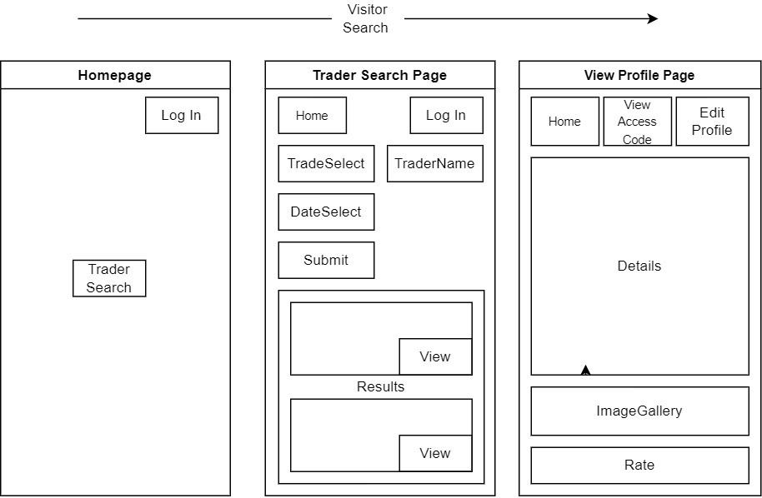

Figure 5.2 Visitor Rate Design

Figure 5.1 Visitor Search Design

Figure 5.3 Visitor Sign Up Design

Figure 5.4 Trader Sign In Design

Figure 5.5 Trader Edit Profile Design

Figure 5.6 Trader View Access Code Design